

Beginners PAT Testing Guide

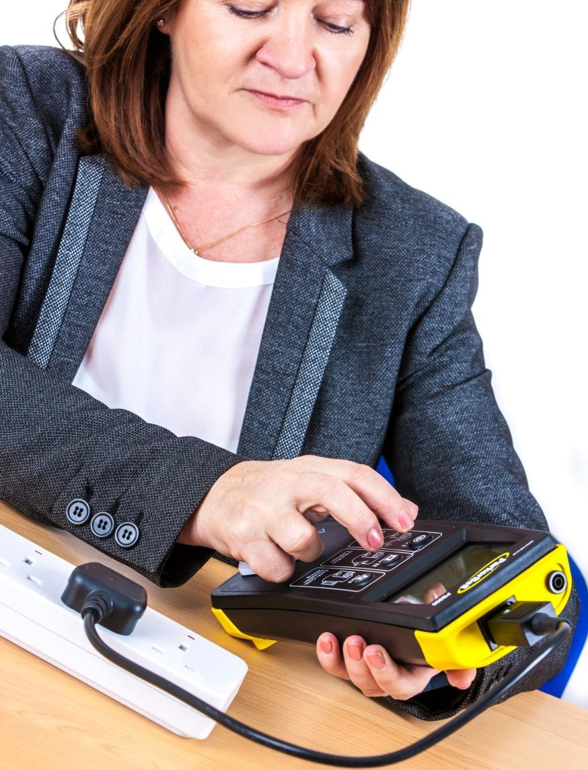

**Tips and advice if you are looking to start PAT testing.**

## What is PAT testing?

PAT testing or Portable Appliance Testing is the recognised method of inspecting and testing that portable electrical appliances are safe to use. There are several stages involved in testing an electrical appliance and this guide will walk you through the process.

***Did you know that as stated by HSE (Health and Safety Executive) you are required to inspect and maintain portable electrical appliances!***

## What is a portable electrical appliance?

A portable electrical appliance is an electrical appliance with a lead and plug.

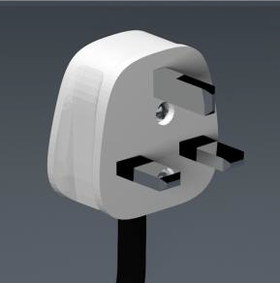

They can be found throughout your home and work environment. Some portable electrical appliances are handheld others like fridges will remain static.

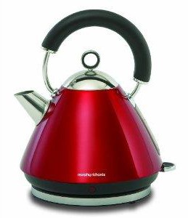

## Can I PAT Test?

The simple answer is yes as long as you feel competent and capable to do so. A competent person can PAT test using a PAT tester that offers a PASS/FAIL reading which eliminates the need to decipher complicated readings.

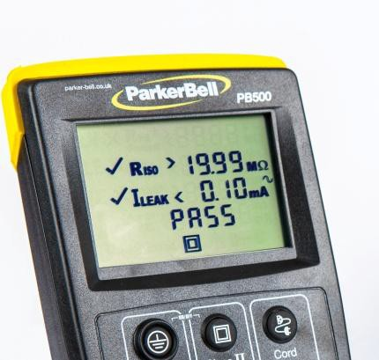

**The PB500 showing a PASS**

If you are unsure if you feel competent then your best solution is to complete our simple and free online PAT testing course. This course will teach you the fundamentals of PAT testing via a step by step process.

**https:/**[**/www.**](http://www.parker-bell.co.uk/pat-tester-training-courses/)**p**[**arker-bell.co.uk/pat-tester-training-courses/**](http://www.parker-bell.co.uk/pat-tester-training-courses/)



Please Note:

If you still aren’t sure you can successfully use a PAT Testing machine and safely check your Portable Electrical Appliances then you should look into further training before proceeding.

## So you have bought a PAT testing machine and you're ready to start PAT testing your electrical appliances. Here are some things to remember.



It is both the responsibility of the Director or Manager of a business and the responsibility of the employees that use the electrical appliances to inspect and maintain them.

The HSE says that employees have joint responsibility for the maintenance and inspection of portable electrical appliances. It is vital that employees take responsibility for checking the appliances they use at regular intervals. Any problems should be escalated to the responsible person to be dealt with.



The frequency of PAT Testing is determined by the type of appliance, the risk of the environment and the risk to the user.

#### You should complete a risk assessment on any electrical appliance to determine the frequency it should be PAT tested.

For example, a handheld drill on a construction site is of a higher risk than a desktop computer in an office.

**Top Tips**

* Appliances used by the general public or vulnerable people should Be tested between 6 months and a year.
* Appliances on Construction sites should be tested every 3 months
* High-risk items like those using water or with a heat element should be tested every 6 months to a year.
* Static appliances may only need to be tested every 2 years.

 

Keeping records of when and what has been PAT tested is essential so that you prove an inspection has been carried out. You can keep records in whichever way works for you and your company. We advise keeping the records in a binder or on a spreadsheet so you can store the calibration certificate of the PAT tester being used alongside.

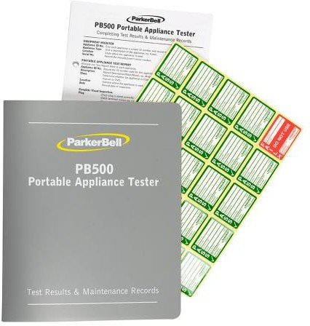**Important!**

**All PAT testers require a valid calibration certificate or tests carried out will be void.**

**PAT testers require an annual calibration.**

## How Do I PAT Test?

PAT Testing must be carried out in the following order:

1. A visual inspection
2. PAT Testing (using a PAT Tester)
3. Functional test (where appropriate)
4. Completion of the pass label and records.

## Step 1 – The Visual Inspection

The visual inspection must be carried out before any other test.

A visual inspection checks that the electrical appliance the plug and the lead have no visible faults or damage. Most faults are usually found at this stage of testing.

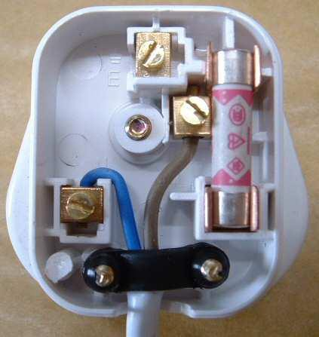

**Checking Plugs**

Unmoulded plugs need to be inspected internally.

Check the correct fuse is being used for the the wattage of the appliance.

Our FREE online course can walk you through this process if you would like more guidance.

**https:/**[**/www.**](http://www.parker-bell.co.uk/pat-tester-training-courses/)**p**[**arker-bell.co.uk/pat-tester-training-courses/**](http://www.parker-bell.co.uk/pat-tester-training-courses/)

## Step 2 PAT Testing using A PAT Testing Machine

To successfully perform a PAT Test you need to know the Class of the appliance you’re testing.



* Class I appliances have an earth wire.
* Class II appliances do not have an earth wire, they usually carry this symbol.

# When you know the Class follow the steps below:

### Class I Appliance Testing.

1. Attach the earth lead to the PAT Tester and the probe/clip to the earth on the appliance.
2. The earth is a suitable exposed metal part of the appliance. (For example on a kettle, this is the element).
3. Plug the appliance into the PAT Tester and press Class I.
4. The PAT Tester will tell you if the appliance has passed or failed.

### Class II Appliance Testing.

1. Plug the appliance into the front of the PAT Tester and press the Class II button.
2. The PAT Tester will tell you if the appliance has passed or failed

### Extension Lead Test

All extension leads are Class I but are tested using the Cord button on the PAT tester, as this also ensures that the lead has the correct polarity.

# Don’t forget to label your tested appliances and record the results.



**The PB500 PAT Tester Machine**

# Simple PASS/FAIL readings

**Reliable Class I & II Appliances**

**Key Tips**

* Switch on the machine by pressing the Class I and Class II buttons simultaneously until you hear 2 beeps.
* Do not leave batteries in the machine if not in use for a long period of time.
* Don’t forget to book an annual calibration.
* See our PAT testing flow chart for more guidance.

For more information about PAT testing or PAT testing machines please visit our website at

[**www.parker-bell.co.uk**](http://www.parker-bell.co.uk/)